I have created a search link project as requested. This takes two inputs search text and search url. After clicking on search button this return all searches list as well as the position of searched url.

**Prerequisites:**

C#, .NET Core 5.0

Angular 11

**Required packages:**

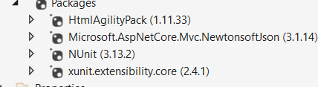

Please see the screen shots for reference:

Backend Jason by visual studio (.Net core):

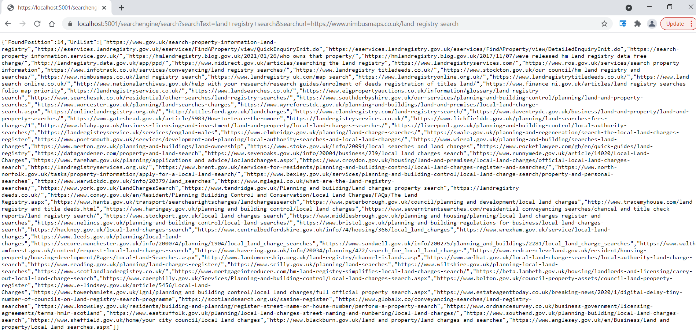

Application Frontend:

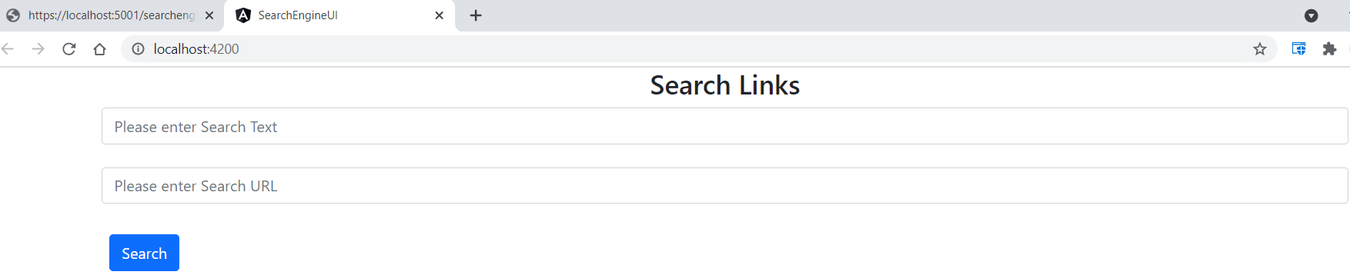

With search text and blank URL:

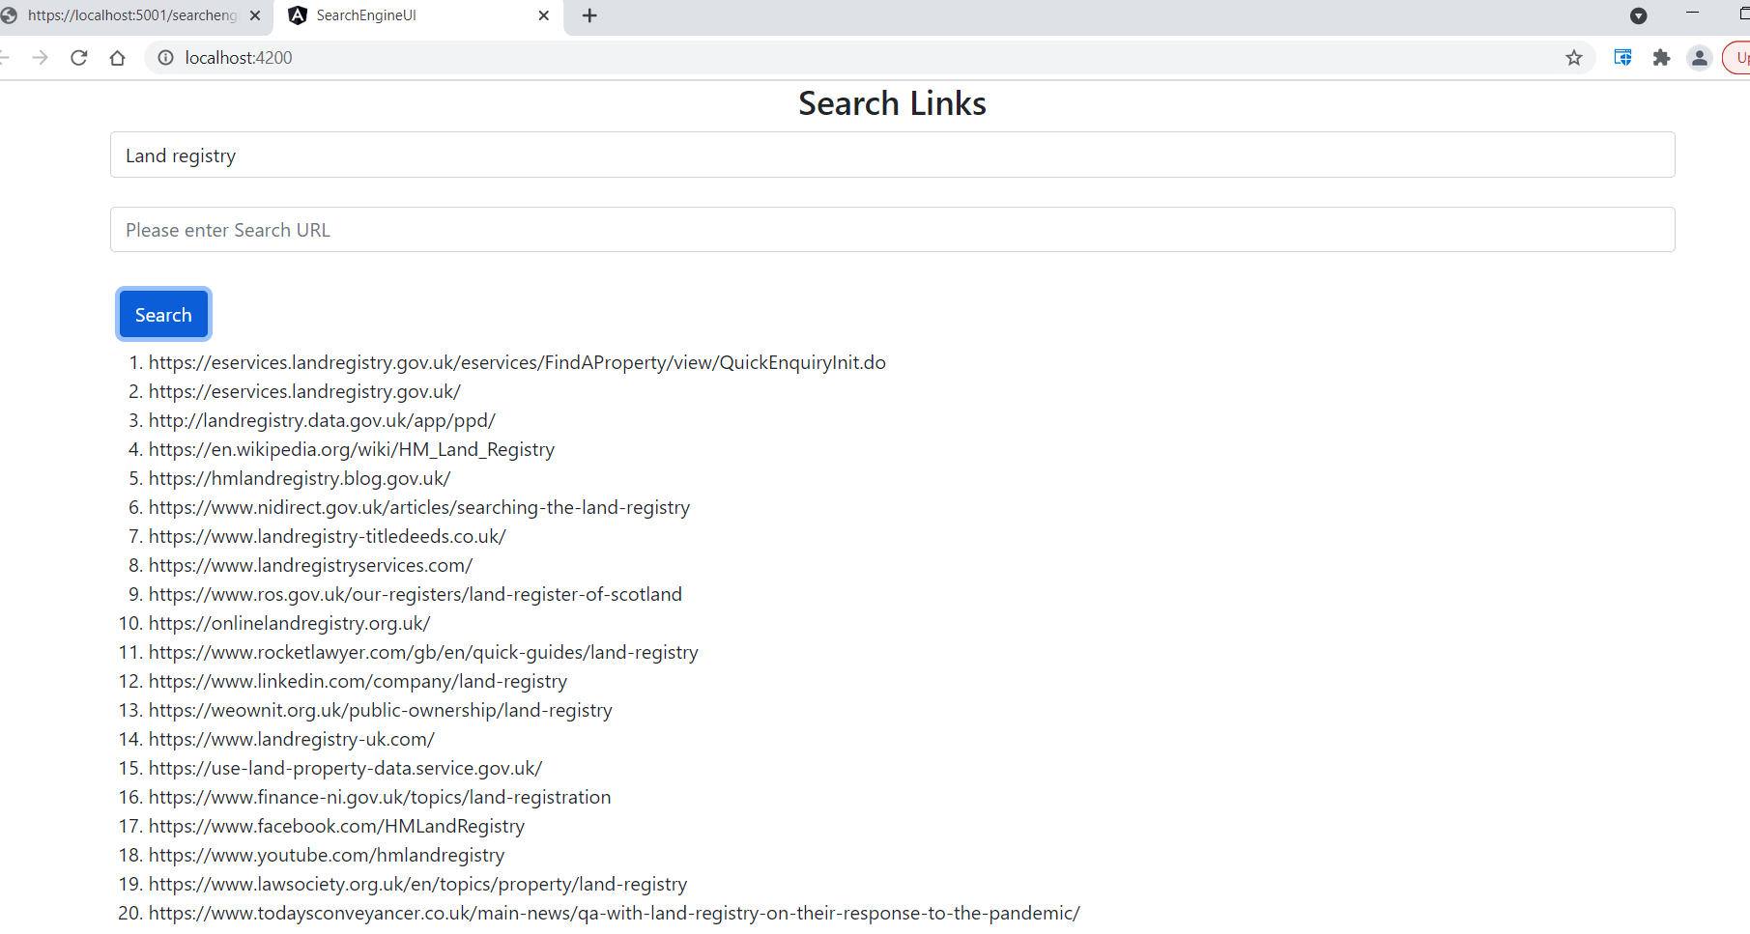

With search text and URL:

